The Public Health Practitioners Accredited Programme Handbook
Summer 2022

Contents
Introduction 3
Workshop details 5
Internal Quality Assurance for the delivery of the workshops 8
Introduction to the Assessment 9
UKPHR Practitioner Registration 12
Internal Quality Assurance Processes for accreditation 13
Frequently Asked Questions 14
Checklist for Candidates 16
Appendix A: UKPHR Practitioners Standards with the relevant guidance for each standard (Excerpt from UKPHR supporting information for practitioners 2022, pages 12-18) 18
Appendix B: Submission Template 25
Appendix C : Appeals Policy for FPH Courses 28
Appendix D: Public Health Practitioner Accredited Programme Assessment Log 29

Introduction

The Faculty of Public Health (FPH), in partnership with regional UKPHR practitioner schemes, has developed a series of workshops to support public health practitioners and related personnel who wish to develop their professional competence and expertise.
This programme will provide six half day workshops to support public health personnel who are:
- Engaging with a programme of accredited CPD to further their knowledge and skills.
- Seeking to develop their knowledge and understanding about public health for example, those who have recently moved into public health from another discipline/area of work.
- Considering UKPHR practitioner registration1 in the next few years.
- Currently working on their portfolio for UKPHR practitioner registration.

The workshops will support attendees in the acquisition and application of knowledge and understanding required by the UK public health practitioner standards 2018 (2nd edition). These standards have been mapped to the Public Health Skills and Knowledge Framework (PHSKF) and are suitable for people working in all sectors and for commissioning or provider roles.
We recognise that people in public health careers have often come from a range of other professions and the workshops are designed to provide the theoretical knowledge to underpin good public health practice.
The FPH accredited Practitioner Programme aims to create an environment in which practitioners can learn, or update learning, in the areas of competence described in the UKPHR practitioner standards, the theoretical and technical disciplines that underpin public health practice.
It will also:
- Provide linked learning to professional frameworks such as the UKPHR standards and PHSKF;
- Enable practitioners to apply knowledge acquired during the learning process, and to reflect on the application of the knowledge, to their practice; and
- Provide training that will generate suitable evidence of underpinning knowledge for inclusion in the practitioner portfolio for registration and provides 5 CPD credits 4 per workshop

There is a maximum of 25 learners per session so that attendees have the opportunity to participate in the interactive discussion sessions. To ensure people can access relevant aspects of the learning, the programme is modularised, and candidates can attend one or all of the sessions. Those completing at least four workshops will qualify to participate in an assessment of their learning to gain a FPH certificate of accredited training, provided by the Faculty of Public Health.
At this level of study, learners will be expected to do both pre and post-session reading to maximise the learning from the workshops. It is expected that for each workshop a further four hours is spent on the additional reading suggested by the facilitators during the workshop. This is essential for those seeking accreditation of their learning.

Workshop details

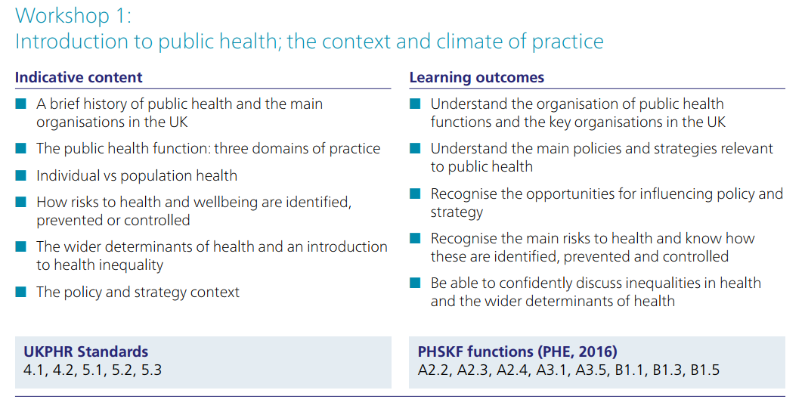
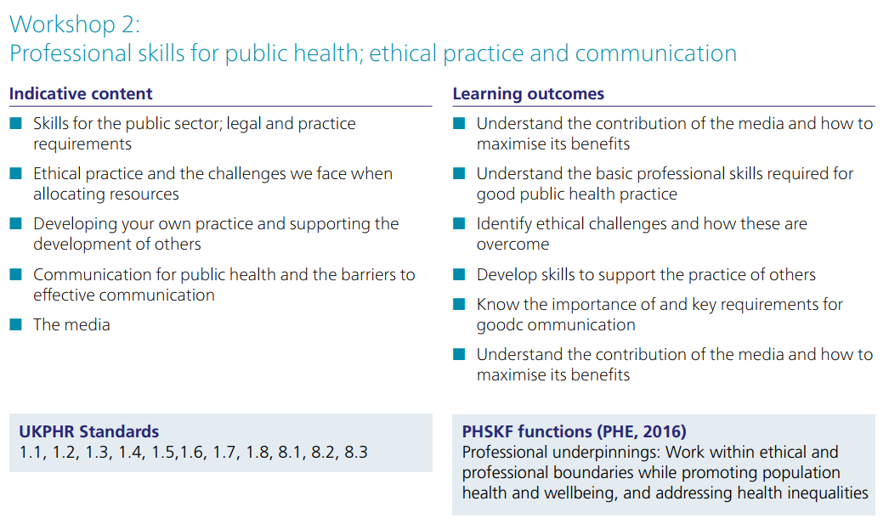
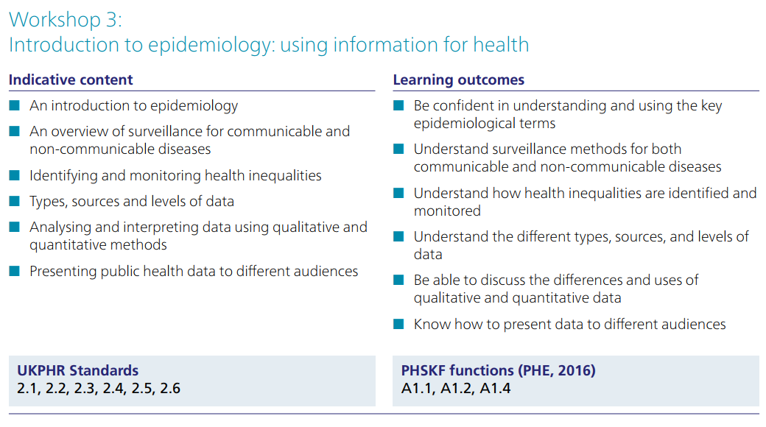
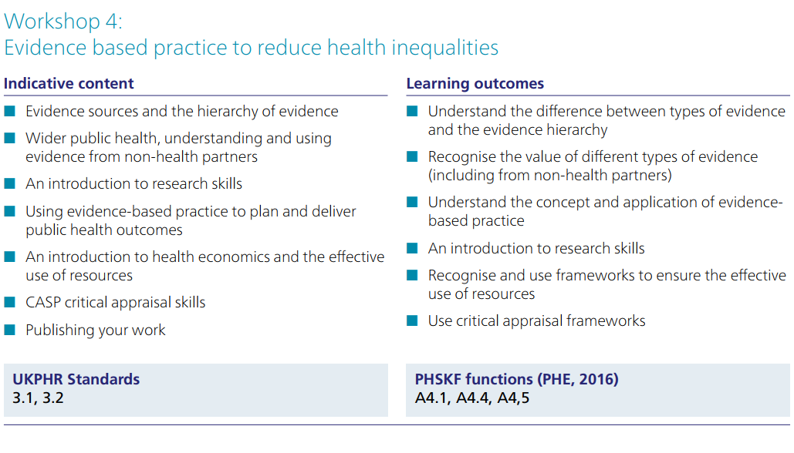
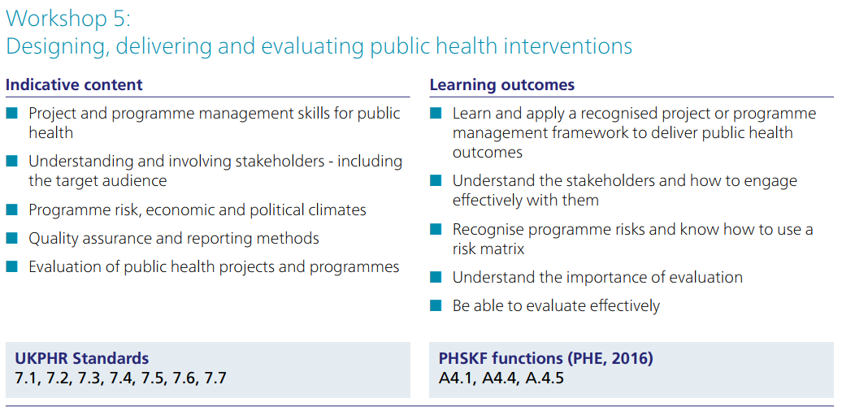

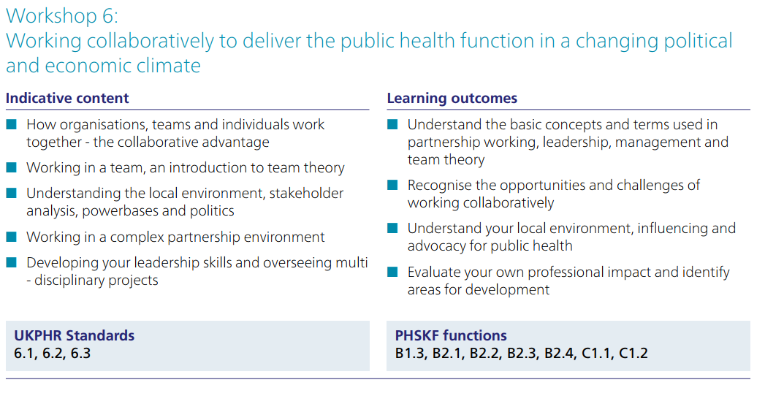

Internal Quality Assurance for the delivery of the workshops

The Faculty of Public Health Education Committee is responsible for developing, maintaining and monitoring educational standards, including curriculum development and review, and the standards of programme delivery and assessment (including the MFPH examination).
These sessions have been designed and developed by a team of collaborators including senior consultants in public health from local authority settings and lecturers from selected universities. They were reviewed in 2019 to better align with the revised UPKHR standards. A rigorous process of piloting and evaluation has been undertaken to ensure each session meets the requirements of both learners and employers.
The evaluation process is ongoing, and includes feedback via an online survey, which informs FPH of any adjustments which will be required for the programme, given the changing nature of the public health workforce and tasks. When changes to the programme are made, we evaluate the changes for a minimum of one year.
The optional FPH assessment is subject to strict IQA processes and overseen by the Faculty IQA Lead. More information on the process can be found in the Assessment section of this handbook.

Introduction to the Assessment
Submission of a summative written assessment is an optional aspect of the programme and is for
practitioners who would like to gain an accredited certification at the required level for UKPHR Practitioner Registration. For practitioners working towards UKPHR registration, this contributes to portfolio requirements for the demonstration of underpinning knowledge of the public health standards.
At the Faculty of Public Health (FPH), the Accredited Practitioner Programme has undergone a robust
quality assurance process for delivery, assessment and verification, and our learners can gain a nationally recognised qualification on completion of the summative assessment task.
Learners should contact FPH at educ@fph.org.uk in the first instance to check whether the cost will be covered by a local scheme or directly payable by the individual. The requirements for submitting work for assessment are set out below.
The Assessment Process
Following attendance at 4 or more workshops, and an application from the practitioner to be considered for
accreditation, the process and task is shown below
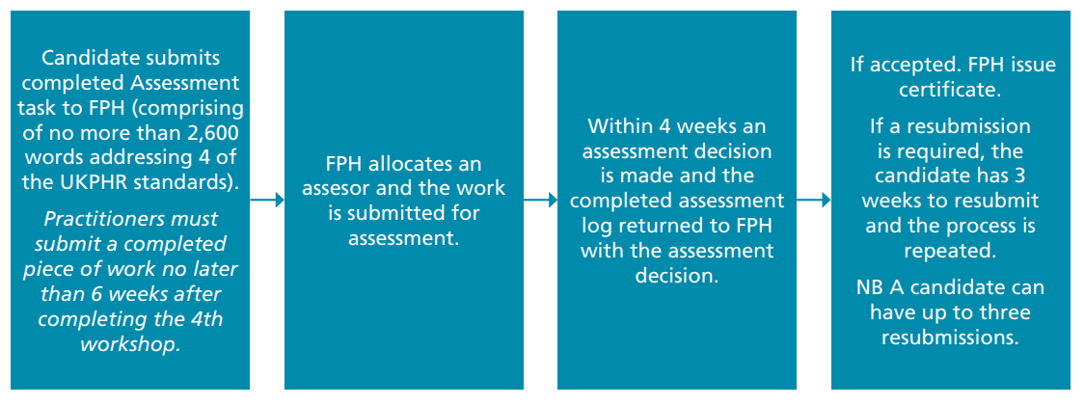
The Assessment Task
“For four of the UKPHR standards (see Appendix A) produce a reflective account of your underpinning knowledge and understanding (referring to theory and relevant models and processes) and relate this to an aspect of your work.”
Each account should be between 400 – 600 words. An additional section reflecting on your learning should also be provided, demonstrating your skills in reflective writing (maximum words 200). Total word count maximum 2,600.
The criteria for assessment will be that you have, for each standard:
- Shown knowledge and understanding of the relevant knowledge base for the chosen UKPHR standard.
- Explained how this knowledge applies to a specific example of your current work (for each standard).
- Demonstrated your skills in reflective writing.
Assessment Guidance
To meet the requirements for accreditation, a candidate must successfully demonstrate knowledge and understanding of all four of the standards selected as well as the requirement for a reflective overview.
The process outlined above can be repeated up to 3 times Please (see Appendix A) for the UKPHR practitioner’s standards and the accompanying guidance and read this carefully before attempting the task.
Assessors should be able to clearly see a reflection on the knowledge gained as well as the implications of this (understanding) in their own area of work. This should be supported by evidence they are applying this in their area of work.
In meeting the requirements, candidates are expected to:
- Identify the source of their knowledge (i.e. which workshop).
- Reflect on the knowledge gained (referring to theory and relevant models and processes) and explain how the knowledge applies to their chosen work example(s).
- Demonstrate their understanding, using examples from their work.
- Provide supporting evidence that corroborates the application of knowledge and understanding in practice. This evidence must situate the candidate in the work. i.e. have their name on or have something that verifies their involvement.
Please see Appendix B for the Submission Template.
Work should be submitted in one document. The submission should be commensurate with Ofqual level 6 i.e.: that the learning ‘seeks and applies new techniques and processes to own performance and identifies how these might be evaluated’.
The Assessment log in Appendix D is completed by the assessor. The example in the log illustrates the additional evidence which must be supplied with the assessment task to evidence how the candidate has applied their knowledge within their work.
The following types of evidence can be submitted:
- Written reports, presentations or email trails of practitioners’ own work, either from a paid work role, or from voluntary work with other organisations.
- A detailed testimonial from a manager or senior colleague who can confirm the work described is your own (authenticity check).
- Written case studies of work by others, based on the practitioners’ own analysis, observation, and discussion with colleagues.
All evidence must be presented in the English language.
- None of the evidence submitted should contain personally identifiable information and should comply with the UKPHR Supporting Information for public health practitioner registration guidance (UKPHR, 2020 page 19).
- Data Confidentiality: Applicants need to demonstrate competence in this area throughout their submission. For more information on one insuring Data Confidentiality please refer to “Guidance for Applicants, Assessors and Verifier Public Health Practitioner Registration” document.
A guidance document for reflective thinking and writing can be found here: https://www.fph.org.uk/media/1283/fph-tips-on-writing-effective-reflective-notes.pdf
Addressing a resubmission
1. Carefully read the assessor comments on the assessment log in order to understand what was
missing from the initial submission.
2. Update the original submission by doing the following:
– Update the submission so that is clear to the assessor what additions/changes have been made by highlighting the text. This may include adding additional narrative and or signposting new or replacement evidence.
– Choose additional evidence (if required) signposting what this evidence demonstrates from the submission and numbering and labelling the evidence in the appropriate box on the template.
– Add a header to the resubmission titled “Resubmission (insert date)”.
– Save the resubmission with all the evidence as one document ready to resubmit.
3. Resubmissions should be made within 3 weeks of receiving the outcome of the assessment.
4. In the event of further requests for resubmission the process outlined above can be repeated twice more (up to 3 times in total).

UKPHR Practitioner Registration
For candidates who are working towards Practitioner registration with the UKPHR, successful accreditation through this process can be used to evidence the knowledge component of the 4 standards submitted.
(The FPH certificate can be used as the objective evidence that the practitioner has the underpinning knowledge of the four standards accredited).
One piece of work with no more than 2,600 words
PLUS
Supporting evidence which does not contribute to the word count.
Reflective overview of how you will use this learning in your future practice
Max of 200 words

4th Standard
Reflective Account
400-600

3rd Standard
Reflective Account
400-600 words

2nd Standard
Reflective Account
400-600 words

1st Standard
Reflective Account
400-600 words

Internal Quality Assurance Processes for accreditation

IQA is a process of measuring the quality of the assessment process for the Public Health Practitioner Accredited programme. The aim is to provide conﬁrmation that the assessment process meets the requirements for the underpinning knowledge and understanding of the selected UKPHR standards. IQA is not a reassessment of the assessment task, it is completed by sampling the submission and accompanying evidence for one standard from each application to assure that the assessment process has been undertaken appropriately.
An IQA will be undertaken twice a year (July and January) All applications submitted in the last 6 months will be scrutinised using the following principles:
Conﬁrmation that the assessment log has been fully completed by the assessor, i.e. for each standard:
- evidence is cited
- the process of assessment is clear
- whether resubmissions were required, for what reason, and when;
- the date each standard was agreed as met is given
Undertake a brief review of the submission and evidence for one standard.
The results of the IQA and recommendations will be shared with the Education and Training Manager and the Assessor.
For candidates who opt to submit work for assessment, the FPH accreditation procedures guide and support this process. Assessors are required to, as well as having the skills and attributes listed above, be UKPHR trained and certiﬁed practitioner portfolio assessors.
IQA Lead – Director of Training – Faculty of Public Health
FPH requires a high level of expertise from our facilitators and assessors to ensure the quality of the programme. Requirements for the facilitator/assessor role are as follows:
- Recognised and valid teaching qualiﬁcation /recognised teacher status.
- Demonstrable grasp of level 6 (degree level) materials and attainment.
- Experience in facilitating learning at this level using a range of interactive methods.
- Appropriate level and currency of expertise in area being taught.
- Evidence of own CPD in both topic area and in teaching and learning.

Frequently Asked Questions

1. Is FPH Accreditation right for me?
Anyone who has attended the FPH workshops and who does not already hold a formal qualiﬁcation in Public Health may wish to consider gaining accreditation.
It is particularly useful for those either working towards gaining UKPHR practitioner registration or considering doing so in the future.
This is because the FPH accreditation can be used to demonstrate objective evidence of the knowledge element of four of the UKPHR standards within a practitioner’s portfolio.
2. When I would need to submit the assessment by?
You are required to submit the assessment task within 6 weeks after completing the 4th workshop of your choice. This means that if you choose to submit your piece of work from the following workshops 1,2,3 and 6 you will be required to submit your piece of work 6 weeks after completing workshop 6.
3. Is it possible to get an extension to this submission deadline?
Yes – late submission due to COVID-19 related delays may be grounds for requesting a later deadline. Please contact educ@fph.org.uk to discuss your options.
4. Do I have to pay for the assessment?
Some UKPHR practitioner programmes are covering the costs of this optional aspect of the programme. The funding is available to practitioners who are enrolled on the UKPHR programme only. Please check with your programme coordinator.
If you are required to cover the costs of this service separately, you will be asked to pay £110.00 prior to submission.
You can pay by contacting our Finance department on 020 36961465.
Assessment Documentation
5. Is there any restriction on which standards I can use in my submission?
You can choose any 4 standards from the 34. It is recommended that you choose ones that you do not have alternative evidence of knowledge for.
Please note that the 34 standards are spread over 8 areas of practice and you need to choose just 4 standards not whole areas of practice.
6. Is there any reason why I can’t pick standards that were all covered on a single workshop?
It is recommended you choose your 4 standards from at least 2 diﬀerent workshops.
7. Is there an expectation that the submission is made in a particular format?
Yes. Please use the template B from this handbook and follow all the guidance including:
- Putting your name on the submission.
- Making your submission as one document.
- Adhering to the maximum wordcount.
- Converting it to a PDF document prior to submission.
8. How much evidence is required to meet the requirements
- Aim to use the minimum amount of evidence to satisfy the requirements. 1-2 pieces per standard is usually sufficient.
- See the checklist below for more guidance on evidence.
Using this certiﬁcation within the UKPHR Practitioner Portfolio
9. Once I have the FPH accreditation how do I use this in my portfolio?
For the 4 standards that have been accredited you can signpost and submit the FPH certiﬁcate within the appropriate commentary, as objective evidence of your knowledge.

Checklist for Candidates

This checklist has been designed to assist candidates in preparing a submission. Read this in conjunction with the criteria for assessment in the Assessment task section on page 9 of this handbook and the Submission Template (See Appendix B).
Considering seeking accreditation | Tick each item
1.Have you attended at least 4 of the FPH workshops?
2. Are you working in a Public Health role with autonomy? (Managed rather than supervised). This can be in a voluntary, community or social enterprise or in a paid Public Health role
If you ticked questions 1 & 2 you are ready to move on.

3. Have you chosen 4 of the 34 standards to base your submission on?
4. Have you carefully read the relevant standards with guidance Appendix A for details of the requirement for each standard?
5. Are you clear about the requirement to:

a) Demonstrate your knowledge and understanding for each of the 4 standards separately.

Carefully read the relevant standards with guidance Appx A for details of the requirement for each standard.

Tip: Stay focused on the standard you are addressing.

b) Identify the source of your knowledge i.e. explain which workshop and additional reading addressed this standard.

c) Reflect on the knowledge gained and explain your underpinning knowledge referring to relevant models and theory.

Tip: In reflecting on the knowledge gained from the workshop and additional reading, you are expected to refer to theory/ models / approaches that underpin the standard you are focusing on.

d) Demonstrate how you have applied underpinning knowledge and understanding, using an example from your work.

e) Provide supporting evidence that corroborates the application of knowledge and understanding in practice.
• This evidence must situate you in it. i.e. have your name on or have something that verifies your involvement.
• If a piece of evidence is longer than 1 page, signpost the relevant page numbers.
• Use the minimum amount of evidence to satisfy the requirements. 1-2 pieces per standard.

Tip: pick an example where you can demonstrate that you have used knowledge and understanding of this standard and describe how you did this. Choose 1 - 2 pieces of evidence that demonstrate your involvement and signpost this evidence. This could be a report you have written, a detailed testimonial confirming what you did, or an alternative piece of evidence.

Before Making your Submission

6.Have you located the Submission Template (Appendix B) that you must use to submit your work?
7. Are you clear what you to include in the reflective overview?
Tip: The expectation is that you provide a short reflective overview (maximum 200 words) that provides an overview of the reflections on your learning from the workshops and how you intend to embed this knowledge and understanding into your future practice.
Once you have addressed all the requirements, follow this final checklist:

8. Have you put your name on your submission and dated it?

9. Does your submission meet the maximum wordcount (2600 words for the whole submission including the reflective overview, excluding the evidence)?
10. Have you organised your submission as one document? You can do this by embedding the evidence into the template or attaching the evidence as appendices and saving as a PDF
11. Have you checked to ensure you have not included any personally identifiable information or information that could be considered commercially sensitive?

Tip: If you refer to others use role titles rather than names?
Please note there is no need to attach certificates of attendance at the FPH workshops.
Please do not use hyperlinks in your submission.
If you receive one or more resubmissions following assessment you must, within 3 weeks of receiving the outcome of your assessment:

- Carefully read the assessment log to understand why you have received a resubmission
- update your original submission highlighting the text to make your changes/additions clear to the assessor
- Remove any evidence that is no longer required and add in any new evidence to satisfy the resubmission requirement
- Update the title of your submission to “Resubmission of assessment task (insert date)”
- Submit the updated document as a PDF document

Appendix A: UKPHR Practitioners Standards with the relevant guidance for each standard (Excerpt from UKPHR supporting information for practitioners 2022, pages 12-18)

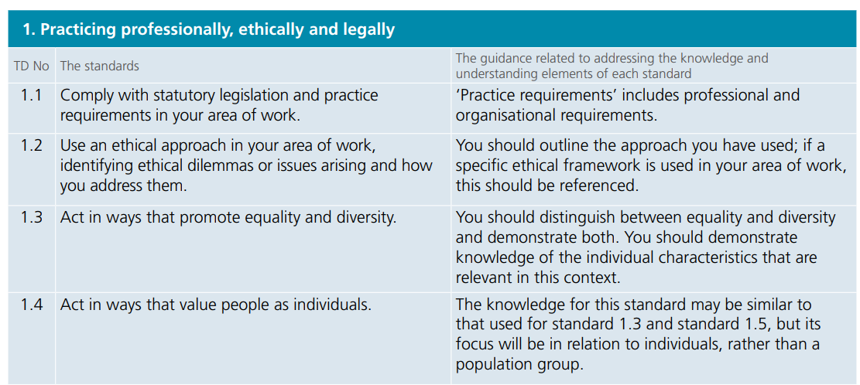
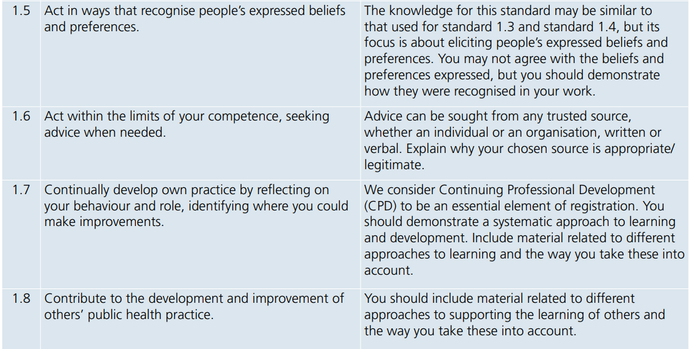

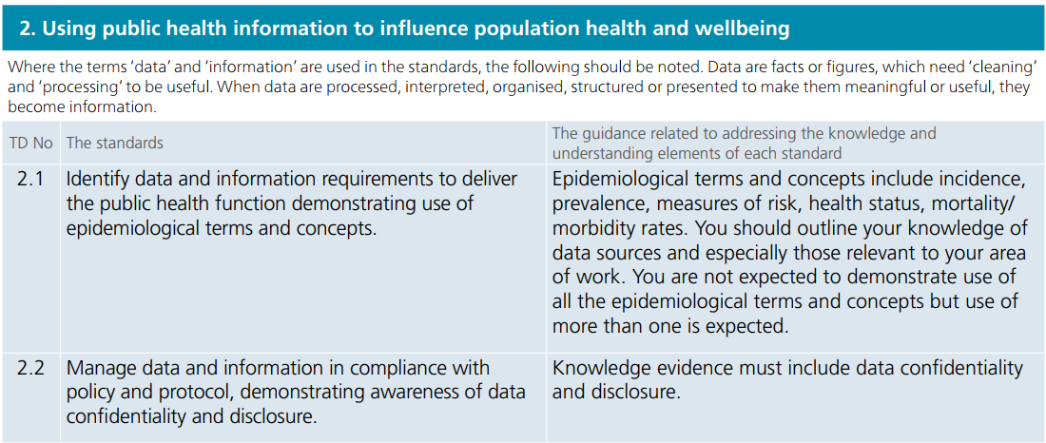

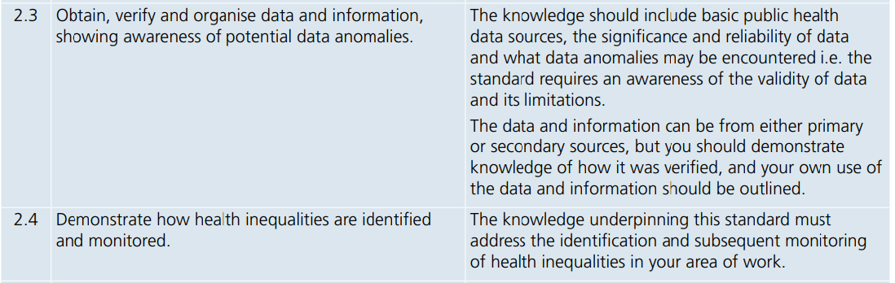
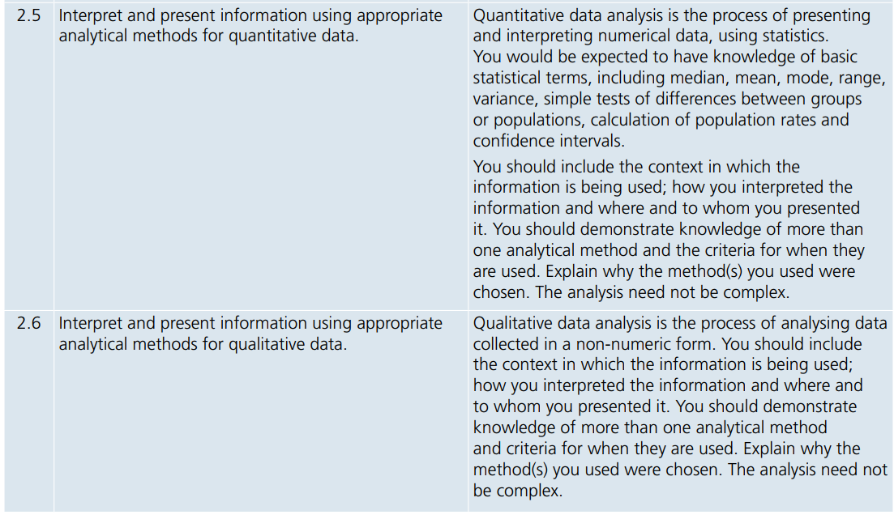

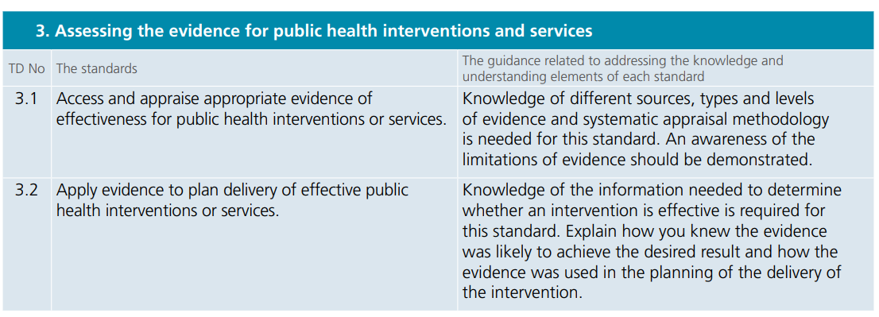

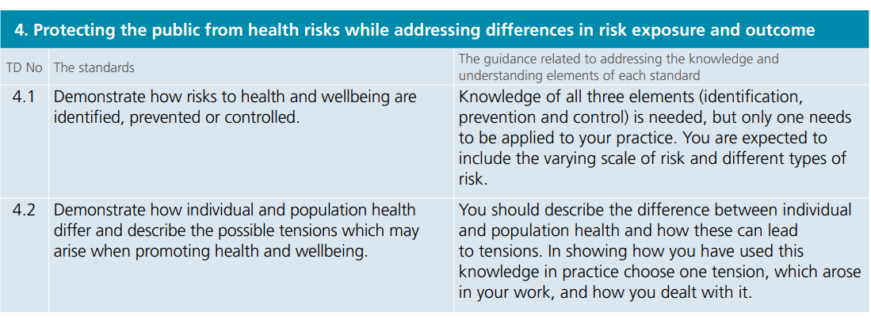
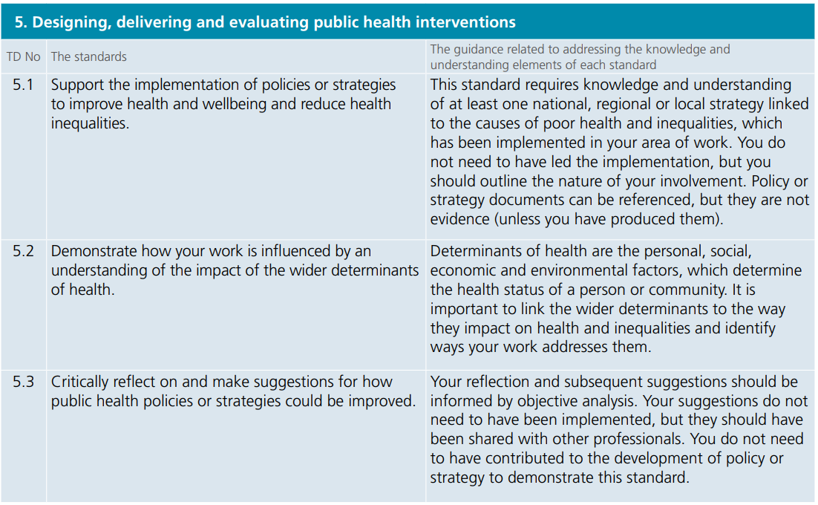
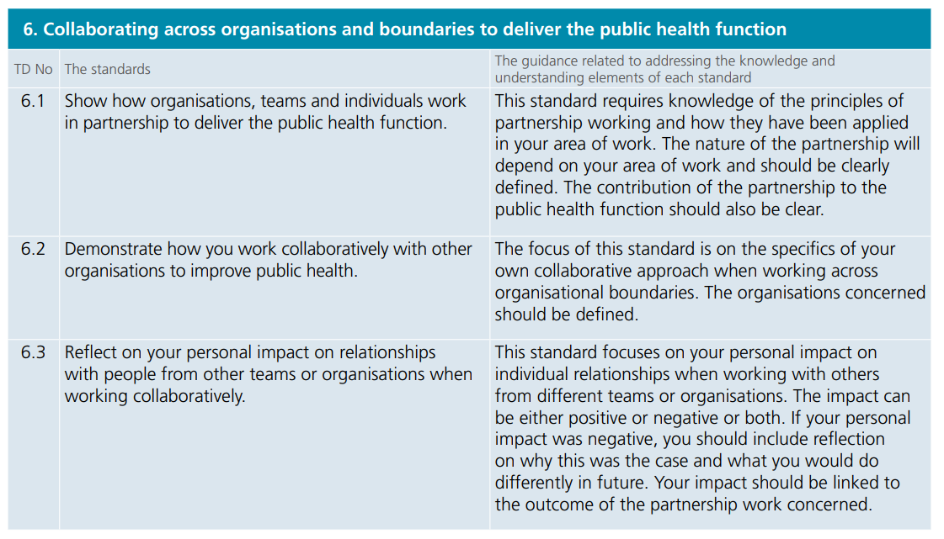

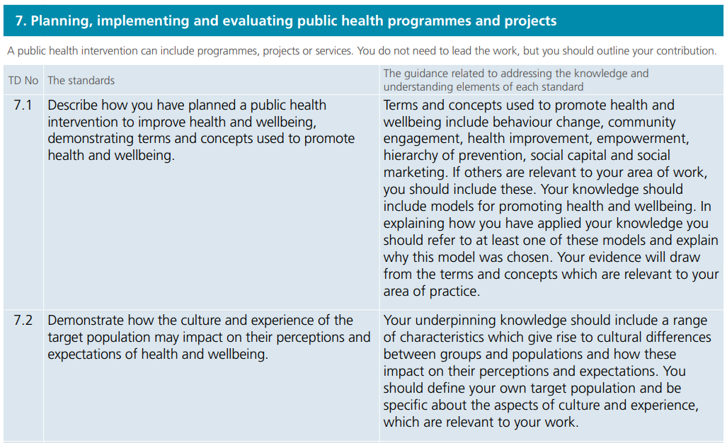

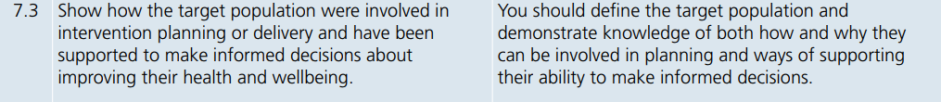

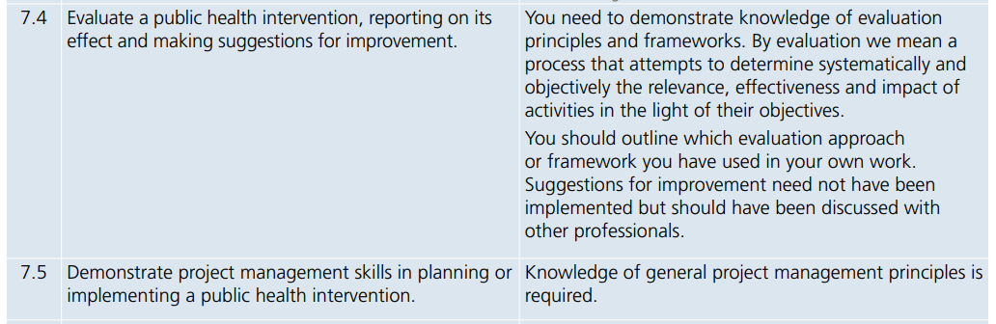

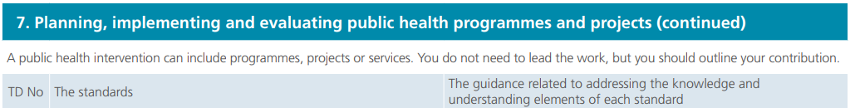

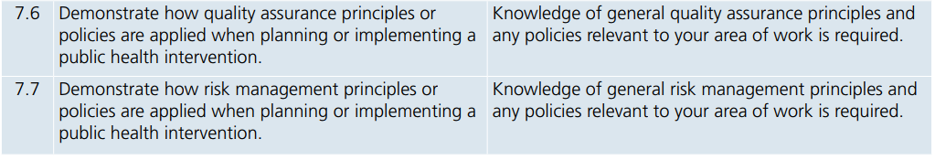

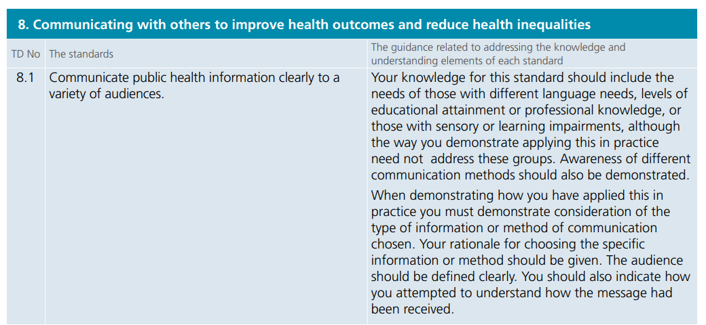

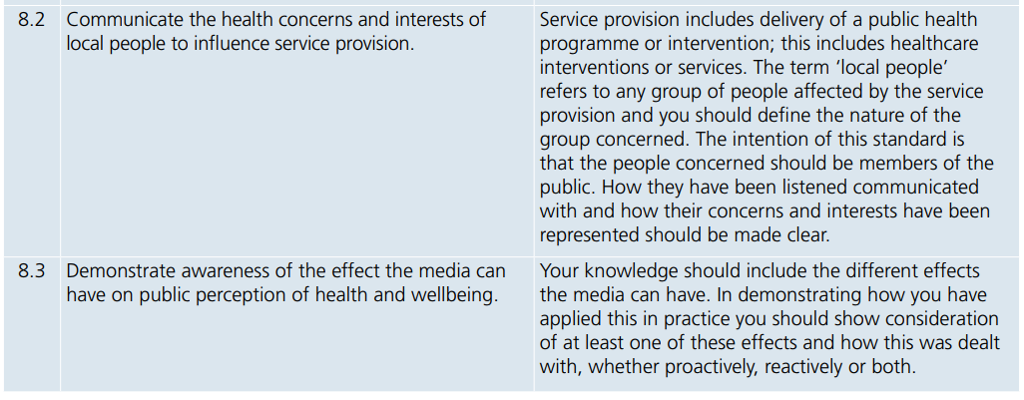

Appendix B: Submission Template

All candidates must use this Submission Template to submit their work. Completed assessments should be submitted to educ@fph.org.uk

Please read the following carefully guidance before submitting:

- Candidates should refer to assessment guidance on pages 9 - 11, the candidate checklist on pages 17-18 and Appendix A for further information about the requirement for each standard.

- All supporting evidence should be added to this submission template and this should be converted into one PDF document prior to submission. Evidence submitted in other formats OR as multiple documents will not be accepted.

- Guidance on how to convert your documents to PDF can be found here: https://support.office.com/en-us/article/Save-or-convert-to-PDF-D85416C5-7D77-4FD6-A216-6F4BF7C7C110 .

- Allow 400-600 words for each standard, plus up to 200 additional words for the reflective overview. The maximum wordcount for the whole submission is 2600 words (excluding supporting evidence). Submissions that exceed this word count will not be accepted.

- Please ensure that all personally identifiable information has been redacted from your submission.
UKPHR Standards referred to in this assignment:
List the 4 UKPHR standards which this submission will address. These must be ones which you learned about in one of the Workshops attended.
You are required to:
- Identify the source of your knowledge i.e. which workshop.
- Reflect on the knowledge gained and explain your underpinning knowledge referring to relevant models and theory.
- Demonstrate how you have applied underpinning knowledge and understanding, using an example from your work.
- Provide supporting evidence that corroborates the application of knowledge and understanding in practice. This evidence must situate you in it. i.e. have your name on or have something that verifies your involvement. If a piece of evidence is longer than 1 page, signpost the relevant page numbers. Use the minimum amount of evidence to satisfy the requirements. 1-3 pieces per standard.
Evidence Formatting
Number and title your evidence items in the following format: Ev.1 document name e.g. Ev. 1 Testimonial from line manager, Ev. 2. Evaluation Report.

Assessment Template

Name of Candidate |  | Date of 1st Submission
Date of 2nd Submission |  | Date of Final Submission

If you are resubmitting your assessment with additional content, please ensure that this is highlighted in
your reflection so that the assessor can easily see the amendments.

Once you have completed your Assessment Template please convert this into a PDF and return to: educ@fph.org.uk

1st Standard (Insert Standard addressed e.g. 3.1)
Write your submission here (400-600 words max):

List of Evidence:

2nd Standard (Insert Standard addressed e.g. 3.1)
Write your submission here (400-600 words max):

List of Evidence:

3rd Standard (Insert Standard addressed e.g. 3.1)
Write your submission here (400-600 words max):

List of Evidence:

4th Standard (Insert Standard addressed e.g. 3.1)
Write your submission here (400-600 words max):

List of Evidence:

Reflective overview of how you will use this learning in your future practice
(200 words max):

Appendix C: Appeals Policy for FPH Courses

Note: This policy does not apply to the MFPH examinations. Please refer to the separate FPH Policy for examination appeals: https://www.fph.org.uk/trainingcareers/the-diplomate-dfph-and-final-membershipexamination-mfph/useful-information-relating-to-bothexaminations/appeals/

AIM
- To enable the learner to enquire, question or appeal against an assessment decision.
- To attempt to reach agreement between the learner and the assessor at the earliest opportunity.
- To standardise and record any appeal to ensure openness and fairness.
- To facilitate a learner’s ultimate right of appeal to the awarding body, where appropriate.
- To protect the interests of all learners and the integrity of the qualification.
In order to do this, FPH will:
- Inform the learner at induction, of the Appeals Policy and procedure. (see Learners’ Guide To Appealing An Assessment Decision).
- Record, track and validate any appeal.
- Forward the appeal to the awarding body when a learner considers that a decision
continues to disadvantage her/him after the internal appeals process has been exhausted.
- Keep appeals records for inspection by the awarding body for a minimum of 18 months.
- Have a staged appeals procedure.
- Will take appropriate action to protect the interests of other learners and the integrity of the qualification, when the outcome of an appeal questions the validity of other results.
- Monitor appeals to inform quality improvement.
- This policy will be reviewed every 12 months.

Appendix D: Public Health Practitioner Accredited Programme Assessment Log

FOR COMPLETION BY OFFICE:

Practitioner Name: |  | Date received
Initial checks: (Tick or cross 1-3 below)
- Named and dated |  | - One document in PDF format |  | - Does not exceed max wordcount, excluding evidence |  | If does not pass initial checks, date returned to practitioner

Date sent to assessor: |  | Assessor name: |  | IQA lead name

1st Assessment

Date of Assessment: |  | Resubmissions Required? | Y ☐ N ☐

2nd Assessment (if applicable).
If Resubmission not received please indicate the date when this application was closed.

Date Resubmission Received from the Practitioner: |  | Date resubmission sent to the Assessor:
Date of Assessment: |  | Resubmissions Required? | Y ☐ N ☐

3rd Assessment (if applicable).
If Resubmission not received please indicate the date when this application was closed.

Date Resubmission Received from the Practitioner: |  | Date resubmission sent to the Assessor:
Date of Assessment: |  | Resubmissions Required? | Y ☐ N ☐

Internal Quality Assurance (if applicable)

Date Portfolio sent to the IQA lead: |  | Date of Verification:

Accreditation

Accreditation successful? | Y ☐ N ☐ | If No, please indicate the reasons (e.g. failure to resubmit)
ASSESSMENT (for completion by the assessor)

Selected UKPHR Standard | Workshop Title | Knowledge | Understanding | Supporting Evidence | Assessment decision
Overview of assessment task. (include dates of assessment)

INTERNAL QUALITY ASSURANCE Log (For completion by the IQA Lead)
Name of IQA lead |  | Practitioner Name
Assessor Name |  | Date of IQA

Is the assessment log fully completed for each Standard? | Y ☐ N ☐ | If no add comment
Were there any resubmissions? | Y ☐ N ☐
If yes, does resubmission evidence appear to be sufficient? | Y ☐ N ☐

For which Standard the evidence was sampled?

Overall view of submission
and additional comments:

Signature | Date

https://www.ukphr.org/i-want-to-apply-for-registration/practitioner/
https://www.gov.uk/government/publications/public-health-skills-and-knowledge-framework-phskf
https://professionalstandards.org.uk/
https://www.fph.org.uk/professional-development/cpd/
https://www.ukphr.org/wp-content/uploads/2014/08/UKPHR-Framework-and-Guidance-for-Applicants-Assessors-Verifiers.pdf, 3.3, page 15

